Table of Contents

The ASTER MANAGEMENT CONSOLE (AMC) 2

1. LOG IN TO THE AMC 2

2. THE AMC DASHBOARD TAB 2

2.1 Navigation Tabs in the Dashboard Window 3

2.2 Major things to monitor in the AMC Dashboard Tab 6

2.3 Other things to monitor in the AMC Dashboard 7

3. THE AMC PROCESSES TAB 7

3.1 Sub-Tabs in the Processes Window 7

3.2 Major things to monitor in the AMC Processes Tab 10

3.3 Cancelling a running SQL using AMC 10

4. THE AMC NODES TAB 11

4.1 Sub-Tabs in the Nodes Window 11

4.2 Major things to monitor in the AMC Nodes Tab 12

The Aster Management Console (AMC)

The Aster Database Management Console (AMC) is the main administrative interface to Aster

Database. The AMC provides developers and other users with insight into Aster Database activity, such as details on currently executing SQL statements and statement histories.

1. Log in to the AMC

Connect using user db_superuser. The connections could be done using a web browser

In the Subsequent sections, we will go through the tabs we can view once we login to the AMC.

1. The AMC Dashboard Tab

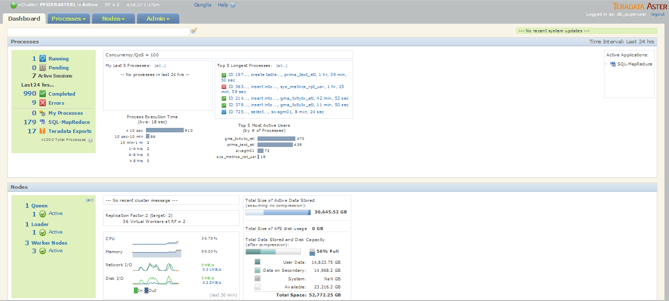

The AMC Dashboard is the main information center where you can view the condition of the

cluster and the jobs currently running on it. Many field labels in this window are clickable. By

clicking a label or message, you can usually see more details about the message or navigate to

the commands related to it.

**Top of the Dashboard window**

As shown in the image below, the top of the Dashboard consists of the following items.

Clockwise from the upper left, they are:

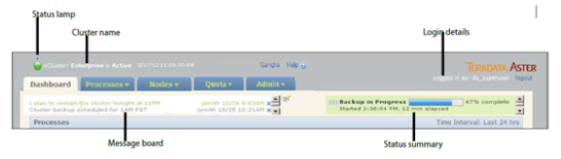

• Status Lamp: The status lamp lights green to show the cluster is running correctly.

• Cluster Name: The name assigned to the cluster.

• Help Link: Click this link to open an HTML page containing information about the AMC

page you are currently viewing.

• Login Details: It shows the logged-in AMC user account name. Your user account determines what

actions you can perform in the AMC.

**2.1 Navigation Tabs in the Dashboard Window**

Below the Status Icon are Navigation Tabs that provide access to various types of tasks that are

accessible through the AMC. Each tab provides details on a different aspect of Aster Database.

**The Processes Section of the Dashboard Window**

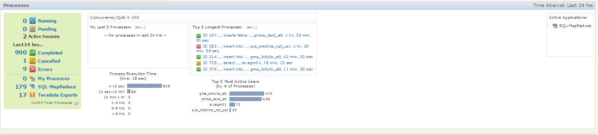

The Processes section of the dashboard shows an overview of the current and recent jobs in

the cluster, as well as statistics including the Most Active Users rankings and the Process

Execution Time graph. The Active Applications box shows currently installed applications that

run on the cluster. The Processes section corresponds to the Processes tab, and clicking most

labels in this section will take you to the Processes tab.

**Process Summary Box**

The green summary box(extreme left) provides a quick overview of the queries running in the cluster.

The green summary box lists the counts of the following states (click any label to show its

details).

• Running: Count of currently running queries and processes

• Pending: Count of queries queued for admission to the cluster

• Active Sessions: Number of users and applications currently connected to Aster Database.

• Completed: The smaller of the count of queries that finished running without error in the

last 24 hours (or time period you specified) or the last 1000 statements.

• Cancelled: Count of queries cancelled by an administrator or user in the last 24 hours.

• Error: Count of queries that failed and reported an error in the last 24 hours.

• Unknown: Count of queries that started in the last 24 hours, but whose status is now

unknown.

• My Processes: Count of finished queries run by you (based on your AMC username) in the

last 24 hours.

• SQL-MapReduce: Count of finished SQL-MapReduce queries that have run in the last 24

hours.

**Query Statistics Summary**

The Query Statistics Summary area in the Processes Section provides an overview of the most

active users and longest running queries.

The Query Statistics Summary area in the Processes Section shows:

• My Last 5 Processes

• Top 5 Longest Processes

• Process Execution Time

• Top 5 Most Active Users

• Active Applications

**The Nodes Section of the Dashboard Window**

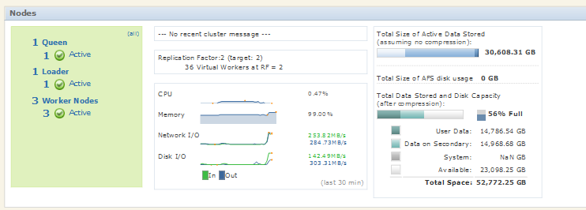

**Nodes Summary Box**

The green summary box lists the counts of nodes in your cluster and summarizes the status of

the nodes.

This section shows the following (click any label to show its details):

• Queen(s): Count of queen nodes in this cluster. The Active count is the number of active

queen nodes in this cluster. This can only be 1 or zero. The Passive count is the number of

passive or secondary queens in this cluster.

• Loader(s): Count of the loader nodes in the cluster.

• Worker Nodes: Count of worker machines in the cluster. Note this is the count of worker

machines, not the count of virtual workers. Below this are listed the counts of Active, New,

Suspect, and Failed nodes.

**Nodes Statistics Summary**

The center panel of the Nodes section shows the current replication factor of Aster Database. If

the current replication factor is below your target replication factor (your Aster Database

administrator specified this when installing Aster Database), a notification appears at the top

of this section.

The Replication Factor section shows, first, the cluster-wide current replication factor. Below

that, it shows how many virtual workers are at RF=2 (these are workers that have a valid

backup worker stored in Aster Database) and how many are lacking a backup (RF=1).

Teradata’s recommended setting is to maintain the cluster at RF=2. If you have some tables

which should not be replicated, create those as analytic tables.

The bottom of this section is the Hardware Statistics panel, showing current and recent CPU

usage, memory usage, network bandwidth usage, and disk I/O usage. Click the Nodes >

Hardware Stats tab(towards the top of the page) for more hardware statistics.

**Cluster-Wide Disk Capacity/Usage**

The right side of the Nodes panel of the AMC Dashboard shows the Data Payload Panel. This

panel provides a cluster-wide view of the data capacity of your cluster and shows how much

disk space is currently being occupied by data and other system files.

This information can be used to quickly determine whether you have a sufficient data storage

capacity in Aster Database or should begin planning to add storage to the cluster. The

information displayed here is meant as an overview for comparison purposes, but if you want

details on storage usage you should use nc_relationstats instead.

Note that if you see N/A displayed for any items under Total Data Stored and Disk Capacity, this is a

temporary status that is displayed while the data is being computed.

The measures shown here include:

• Total Size of Active Data Stored shows the amount of data currently stored in Aster Database.

Active data refers to the raw, uncompressed data size before it is stored on disk. The graph’s

colors indicate the degree of compression applied to different portions of the data.

Hover your mouse pointer over the graph to see the amounts of data stored at each

compression level. The darker the color, the greater the degree of compression applied.

• Total Data Stored and Disk Capacity: Just below the Total Size of Active Data Stored field is the

Total Data Stored and Disk Capacity graph and a breakdown of its contents. The horizontal bar

graph represents your total available disk space in the cluster, and the colors represent used

and unused portions of the disk space.

• The % Full icon provides a visual summary of the disk space remaining on your cluster.

This graph turns orange to indicate that more than 70% of the cluster’s disk space has

**AMC Version Number and Aster Database Version Number**

To find out the version of the AMC you are running, click on the About the AMC link at the

bottom of the AMC window.

**2.2 Major things to monitor in the AMC Dashboard Tab**

1. The status Icon at the top of left of the AMC will tell you the status of the cluster. Check for issues if the color is anything but Green. For details refer Page 464-465 of the Aster guide

(Aster Database User Guide for Aster Appliances 0620 Update.pdf)



1. The Node summary box will tell you the status of the Nodes. Make sure they are active unless there is any activity. See “Node States” on page 480 of the Aster guide.

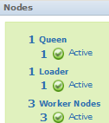

1. Check the % Full icon and make sure it is less than 70%. If it approaches 70%, inform team or make space.

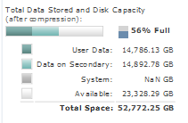

1. Check the replication factor of the system. If it is 2, it’s normal. If it is 1, it means at least one node has lost its replica due to node being failed or removed. With an RF of one, Aster Database remains available for querying and loading, but the loss of another node might result in data loss.

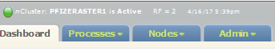

**2.3 Other things to monitor in the AMC Dashboard**

**Processes Section**

1. We can monitor the Errors link to check the queries that went for error. Most of the errors are due to improper syntax but we can use this as a quick link to check queries that gave error.
2. Longest running processes and most active users
3. Processes of our user db_superuser

**Nodes Section**

CPU/Memory/IO usage and total size of active Data

1. The AMC Processes Tab

Monitor and track the SQL statements running in Aster Database using the AMC Processes

tab. The filtering area at the top left is useful for showing and hiding different subsets of the

processes, so you can focus on just the processes of interest to you. The green summary box at

the top right shows counts of current and past statements, categorized by status.

**3.1 Sub-Tabs in the Processes Window**

The Processes tab contains three sub-tabs:

1. **Processes** sub-tab shows a table with statistics and status for current and past commands.

To display detailed information about a connected process, click its ID.

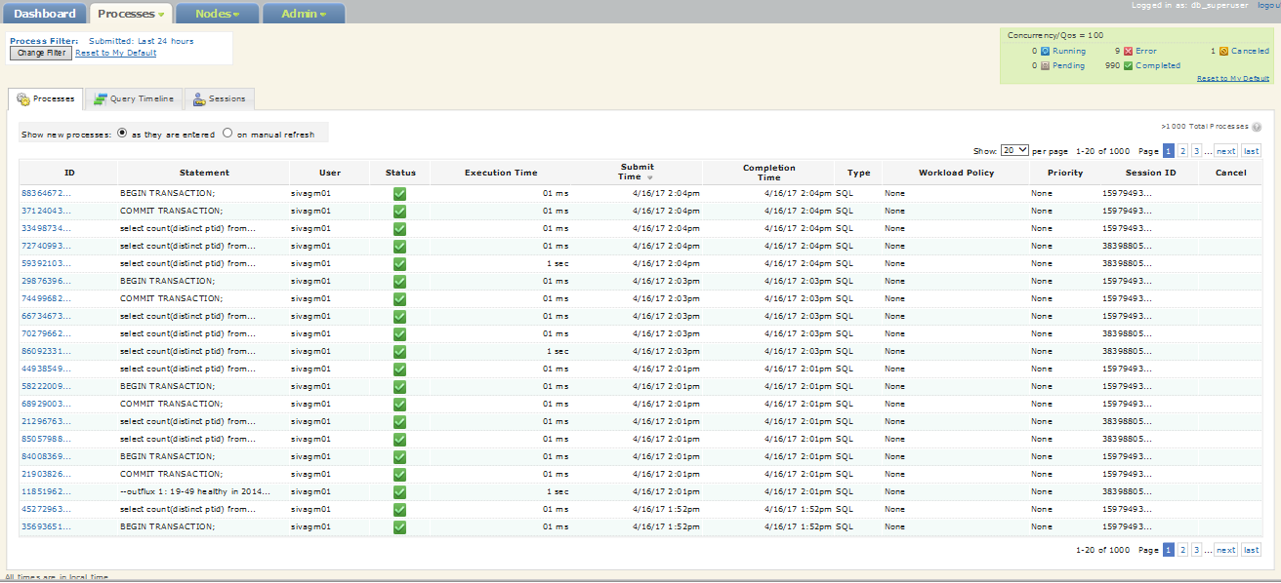

To make the process display even more useful, you can hide or show different processes by

entering filter criteria.

1 Click the Change Filter button.

2 Enter your filter criteria.

This example shows only the CREATE statements that were submitted on the retail_sales

database in the last 24 hours and took more than 5 minutes to complete.

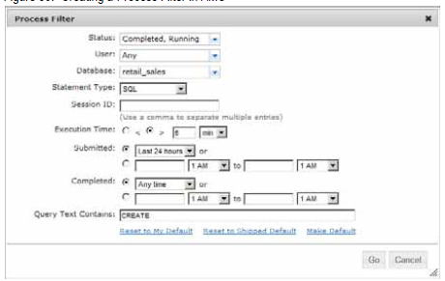

3 To make this filter the default filter, click Make Default.

4 Click Go to view the filtered results.

The current process filter terms are displayed above the Change Filter button, and only the

requested processes are displayed in the list.

1. **Query Timeline** sub-tab shows a graphical representation of commands run in the past 24 hours. Navigation :- (Processes > Query Timeline)

To display processes in the Query Timeline:

1 Navigate to Processes > Query Timeline.

2 To filter the display of processes in the Query Timeline using the Change Filter button, as

described in the previous section(above image).

3 To display details about a process, move the mouse over it. A popup message appears with

additional information.

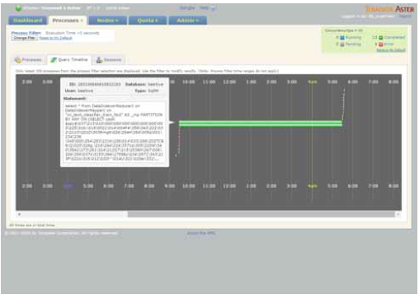

1. **Sessions** sub-tab (Processes > Session) shows a list of the connected or closed user sessions on

this cluster. You can use this list to monitor user activity and help troubleshooting user issues.

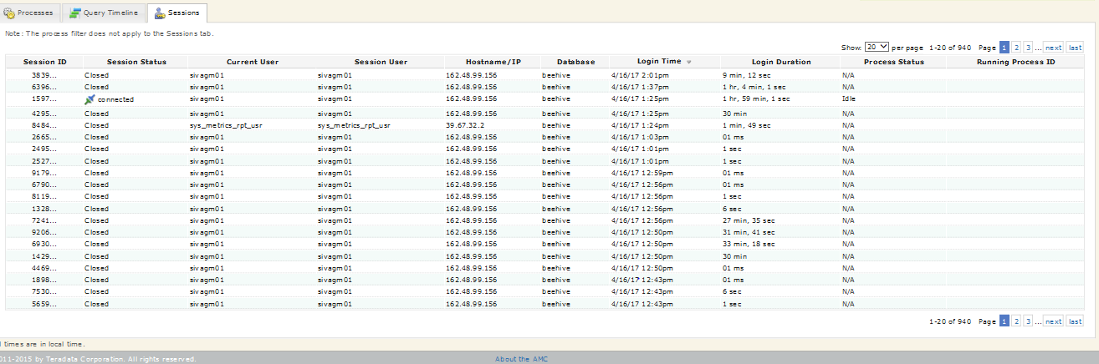

**3.2 Major things to monitor in the AMC Processes Tab**

1. Monitor Process Details by clicking the ID of the process in the Processes sub-tab

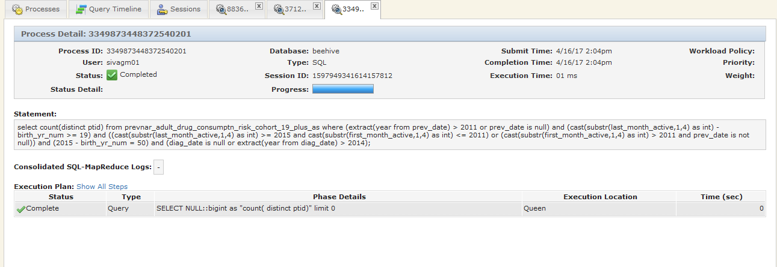

**3.3 Cancelling a running SQL using AMC**

**\*\*NOTE: Do this only if this is part of an approved process as decided by the customer. If allowed, be extremely careful while doing this.**

To cancel a running process, do one of the following:

• In the Processes tab, if a Cancel icon is displayed for a process, click the icon in the Cancel

column (right-most column), then click OK when prompted.

• In the Process Details tab, you can cancel the statement by clicking the Cancel Process

button.

Either action will place the process in Cancelling mode, which indicates that the cancellation

request has been received. Statement cancellation in Aster Database is an asynchronous, besteffort

operation. While executing a statement, the Aster Database back-end checks

periodically to see whether a cancellation request has been issued. If requested, the back-end

acknowledges the cancellation and triggers a best-effort service to cancel the ongoing

execution.

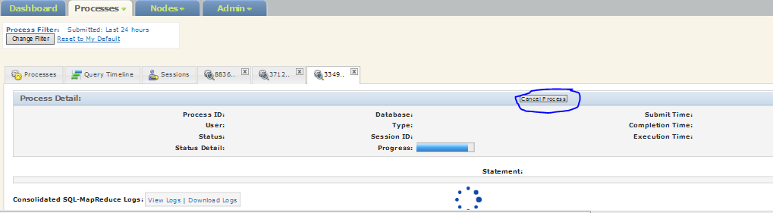

1. The AMC Nodes Tab

The Nodes tab in the AMC gives a system-wide overview of the amount of data stored in Aster

Database. It provides interfaces through which administrators can manage data and replication in the system. The Nodes tab is also used to monitor the operation of Aster Database—its virtual workers,worker nodes, and loader nodes. In the Nodes tab, administrators can view information on

each of the nodes participating in the Aster Database, configure those nodes, and retrieve logs and other information for debugging purposes.

**4.1 Sub-Tabs in the Nodes Window**

1. The **Node Overview** sub-tab displays status and health information about worker and loader nodes.

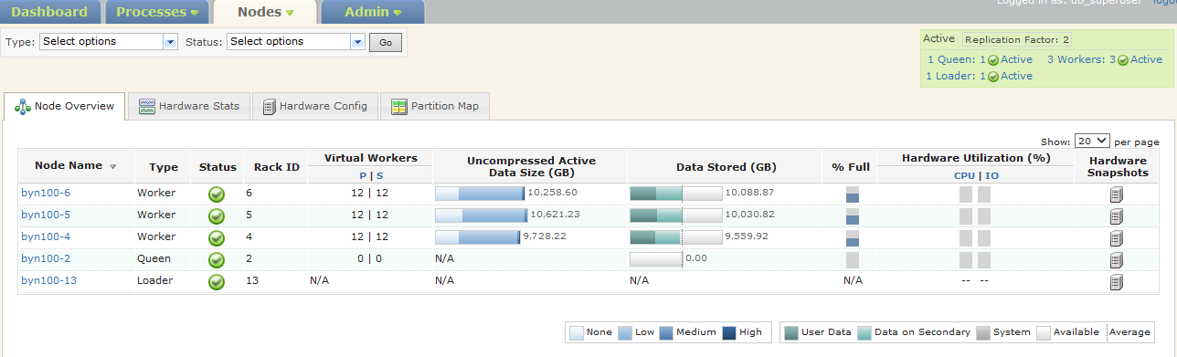

1. The **Hardware Stats** sub-tab contains information on hardware in the cluster.

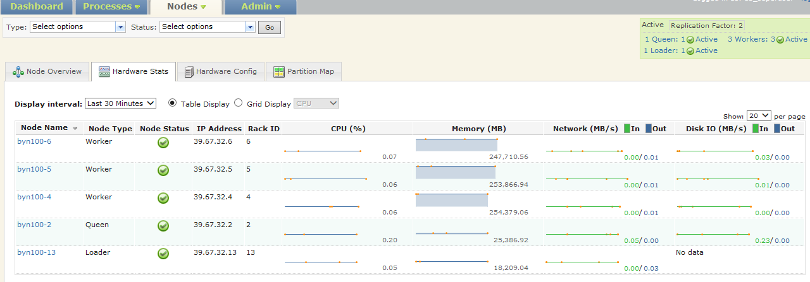

1. The **Hardware Config** tab show information about the current hardware configuration

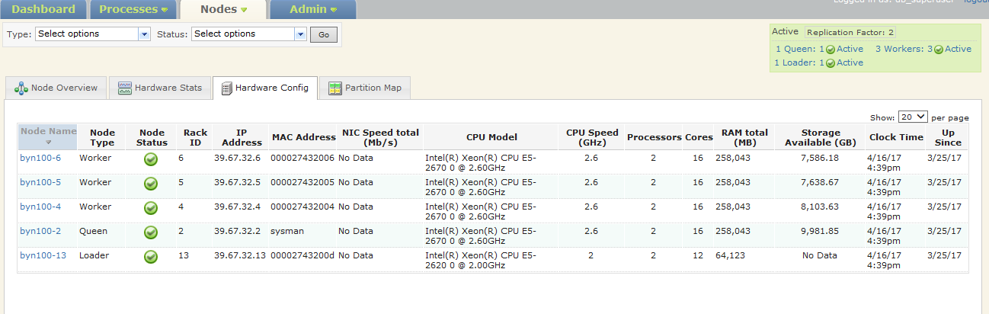

1. The **Partition Map** sub-tab show a graphical representation of the cluster with details for each node.



**4.2 Major things to monitor in the AMC Nodes Tab**

1. Monitor status of each node. There are currently 1 queen node, one loader node and three worker nodes.

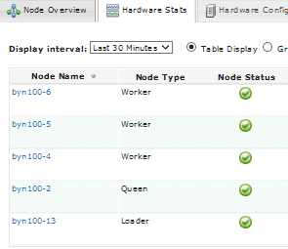

1. Monitor resource utilization of each node(CPU, Memory, Network IO, DISK IO)
2. Check adequate free space. Click on the Nodes > Node Overview tab in the AMC. For each node, click its Data Stored graph and check its remaining free space.
3. To see more details about any specific node, navigate to the AMC Nodes > Node Overview > Node Name column and click its name to display the Node Detail screen. This page will display with a new tab identified by the node’s name. You can also check the logs of a particular node at the extreme right side(circled in the image below)

